WEBQUEST DAY! 50 POINTS!

WEBQUEST #1:
http://circlebasics.weebly.com/
*Fill in handout …
WEBQUEST #2:
http://www.cobblearning.net/stevenwilson/files/2015/12/circle-webquest-1ejobe4.pdf
*Fill in handout …
WEBQUEST #3:
USE THE EXAMPLE BELOW TO ANSWER FIVE QUESTIONS AT:
**write the FIVE questions and answers on the back of this page……
https://www.ixl.com/math/geometry/arc-measure-and-arc-length
***circumference = 2*π*radius OR circumference = π *diameter
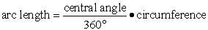

Example:
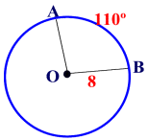 | In circle O, the radius is 8, and the measure of minor arc is 110 degrees. Find the length of minor arc to the nearest integer.  Solution:  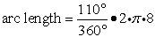 = 15.35889742 = 15

