**Probability and Statistics – Expected Value Worksheet**

1. 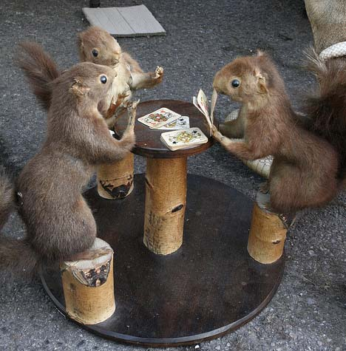A $20 bill, two $10 bills, three $5 bills and four $1 bills are placed in a bag. If a bill is chosen at random, what is the expected value for the amount chosen?
2. In a game you flip a coin twice, and record the number of heads that occur. You get 10 points for 2 heads, zero points for 1 head, and 5 points for no heads. What is the expected value for the number of points you’ll win per turn?
3. There is an equally likely chance that a falling dart will land anywhere on the rug below. The following system is used to find the number of points the player wins. What is the expected value for the number of points won?

|  |  |  |  |  |
| --- | --- | --- | --- | --- |
|  |  |  |  |  |
|  |  |  |  |  |
|  |  |  |  |  |

Black = 40 points

Gray = 20 points

White = 0 points

1. A mysterious card-playing squirrel (pictured) offers you the opportunity to join in his game. The rules are:
   * To play you must pay him $2.
   * If you pick a **spade** from a shuffled pack, you win $9.

Find the expected value you win (or lose) per game.

1. A dice game involves rolling 2 dice. If you roll a 2, 3, 4, 10, 11, or a 12 you win $5. If you roll a 5, 6, 7, 8, or 9 you lose $5. Find the expected value you win (or lose) per game.