Chapter 14.1 – 14.3 Review
**complete the frequency and relative frequency tables below
- Jack asked his buddies how many hours they worked during the previous week at their after-school jobs. The data follows:
4 4 9 8 2 0 4 11 2 1 8 9 1 6
Hours | Frequency | Relative frequency
0-2
3-5
6-8
9+

- On a math test, the scores of 10 students were as follows:
93 66 74 56 89 68 74 99 81 51
Scores | Frequency | Relative frequency
50-59
60-69
70-79
80-89
90-99

- Construct a bar graph for the relative frequency data in the table below (winners of a game played each year)
Winner | Frequency | Relative frequency
Joe | 5 | 0.42
John | 2 | 0.17
Jack | 4 | 0.33
Josh | 1 | 0.08

- Construct a bar graph for the frequency data in the table below (winners of a game played each year)
Winner | Frequency | Relative frequency
Joe | 2 | 0.125
John | 2 | 0.125
Jack | 8 | 0.5
Josh | 4 | 0.25

- Students in Ms. D’s class collected stuff from outside. Below is what they collected. Construct a bar graph for the frequency data.
Rocks, 8
Bugs, 3
Sticks, 1

- The favorite color of people randomly surveyed on a college campus are summarized in a bar graph. How many people were surveyed?
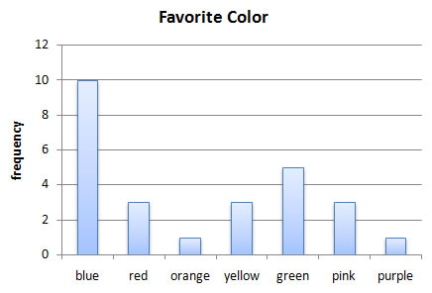

- The ages of people randomly surveyed on the street are summarized in a bar graph. How many people were 41 years or older?
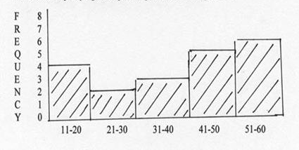

- Find the mean, median and mode of : 5, 7, 3, 5, 2, 8, 4, 1, 2, 2, 8, 5

- What is the mode of this data: 22, 33, 44, 55, 66, 76, 23, 22, 92, 83, 33, 21, 66

- What is the mean for the data in #9?

- Assume that in you Spanish class you have earned the following test scores: 58, 74, 81, 99, 68, and only one test remains. If you need a mean score of 70 to earn a C, then what minimum score must you obtain on the last test?

- Assume that in a 30-day month you begin with a $120 balance due on your credit card, you charge an item for $150 on the 13th, and an item for $200 on the 21st of the month. What is your average daily balance on your credit card for this month?

- Test scores of 20 students are below. Construct a box and whisker plot of the data.
56 77 85 95 98 96 76 55 42 99
87 78 62 76 78 82 66 65 97 33

- Find the range for the data: 8 35 9 4 1 23

- Find the standard deviation of the numbers in #14

- Find the mean and standard deviation of the following data:
Number | 3 | 4 | 5 | 6 | 7
frequency | 2 | 1 | 5 | 2 | 3

